
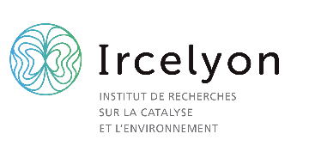
Catalyse thermique ou assistée par micro-ondes
pour la valorisation du CO₂ et de molécules modèles de la biomasse

Thermal or Microwave-assisted Catalysis for the valorisation of CO₂ and biomass model molecules

Laboratoire IRCELYON (UMR 5256) CNRS – UCBL
https://www.ircelyon.univ-lyon1.fr/en/welcome-2/

Main supervisor and 3 co-supervisors:
Dr. Frédéric Meunier (HDR), https://orcid.org/0000-0001-7953-2883 , fcm@ircelyon.univ-lyon1.fr
Prof. Sébastien Leveneur (HDR) https://orcid.org/0000-0001-9528-6440
Dr. Thierry Caillot, https://www.ircelyon.univ-lyon1.fr/en/syrcel-en/card/TCA/
Dr Marilena Radoiu, https://orcid.org/0000-0002-4449-7130

Background and objectives:
CO₂ capture and utilization (CCU) are means to combat global warming. Converting CO₂ to CH₄ is a practical way to recycle CO₂ and store energy in off-peak conditions when H₂ can be produced more cheaply. Properties of adsorbents-catalysts used for the sequential trapping and methanation of CO₂ (Fig. 1), possibly assisted by microwaves (MW), will be studied. The valorization of molecules representative of biomass, such as furfural, will also be investigated through selective hydrogenation or oxidation, either thermally or though microwave heating.
Our group has been working on these topics for years and equipment is up and running [1-8]. The student will receive training in catalyst preparation, testing, in situ and operando spectroscopic investigations (Fig. 2) and microwave technologies. This project will be a collaboration with the private company Microwave Technology Consulting (https://www.microwavetechs.com/), through Marilena Radoiu, recipient of the Irène Joliot-Curie 2023 prize (https://www.enseignementsup-recherche.gouv.fr/fr/le-prix-irene-joliot-curie-recompense-cinq-chercheuses-d-exception-93492), with privileged access to state-of-the-art microwave equipment (Fig. 2, right).

To apply, send: (i) CV + (ii) Mark records + (iii) Motivation letter to Dr Meunier.
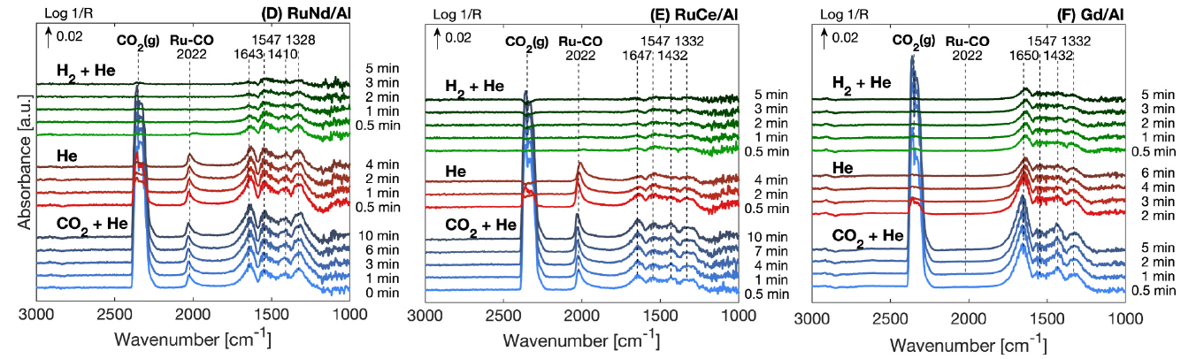
Figure 1: Examples of operando IR spectra obtained during a collaboration with McGill University in Montreal, Canada. This technique allows monitoring species adsorbed at the surface of the sorbent and catalysts during reaction [1]

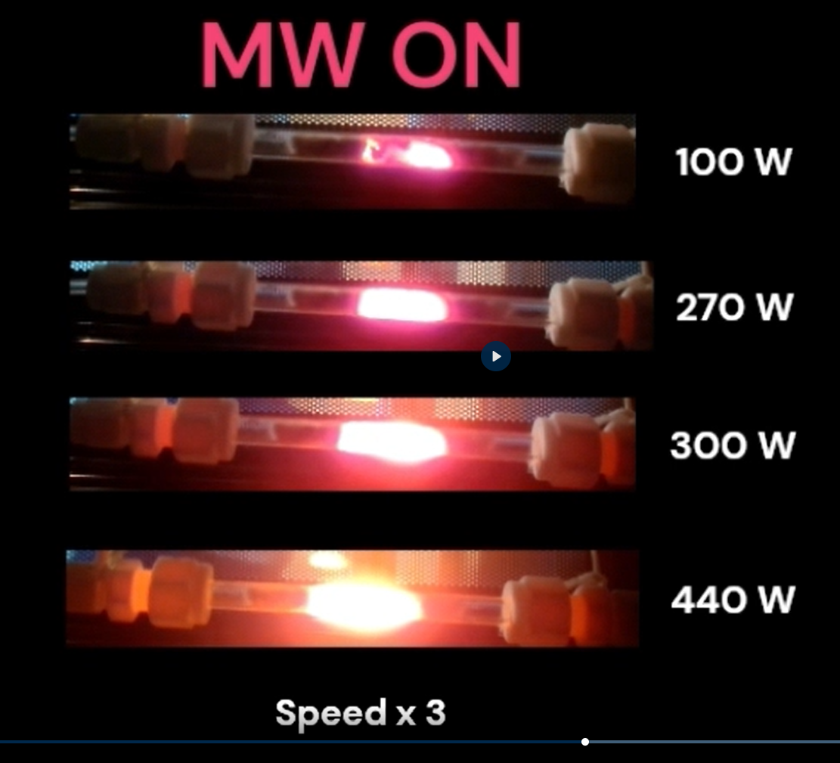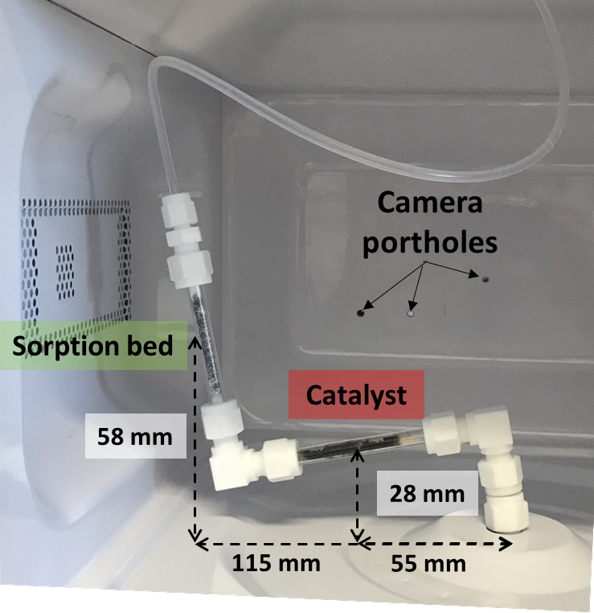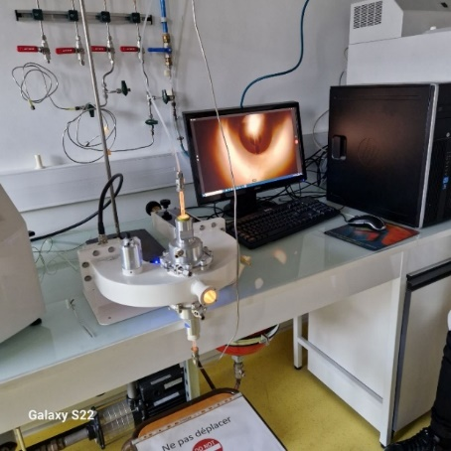
Figure 2: (Left) Reactors under MW irradiation, video: https://sdrive.cnrs.fr/s/5gHqBEbqXtFQfoH. Photos of reactors located in (Middle) a domestic MW oven [2,3] and (Right) a research grade MW equipment ( https://www.microwavetechs.com/ ).

Recent relevant references from the host group:
[1] Achievements and challenges in deciphering heterogeneous catalytic reaction mechanisms using operando infrared spectroscopies. Meunier, F.C., Goguet, A. Nat Commun 16, 11126 (2025). https://doi.org/10.1038/s41467-025-67337-9
[2] Rare earth oxide promoted Ru/Al₂O₃ dual function materials for CO₂ capture and methanation: An operando DRIFTS and TGA study. Lizbeth Moreno Bravo, Frederic Meunier, Jan Kopyscinski. Applied Catalysis B: Environment and Energy 2025, 51, 124591. https://doi.org/10.1016/j.apcatb.2024.124591
[3] CO₂ capture and methanation over iron and cobalt-containing catalysts operated in a domestic microwave oven. Loren Acher, Jessim Gana, Thierry Caillot, Akim Kaddouri, Frederic Meunier, Applied Catalysis A, General, 2024, 685, 119898 https://doi.org/10.1016/j.apcata.2024.119898
[4] Cu-Bound Formates are Main Reaction Intermediates during CO₂ Hydrogenation to Methanol over Cu/ZrO₂. Frederic Meunier, Isaac Dansette, Anaelle Paredes-Nunez, Yves Schuurman. Angew. Chem. Int. Ed. 2023, e202303939 https://doi.org/10.1002/anie.202303939
[5] Hydrogenation of CO and CO₂: Contributions of IR operando studies. Frederic Meunier, Catalysis Today 2023, 423, 113863 https://doi.org/10.1016/j.cattod.2022.08.005
[6] Production of furfural: From kinetics to process assessment. Daniel Edumujeze, Marie-Christine Fournier-Salaün, Sebastien Leveneur, Fuel 2025 381, 133423 https://doi.org/10.1016/j.fuel.2024.133423
[7] Towards sustainable furfural production: investigating solvent effects, reaction kinetics, process simulation, and energy assessment. Daniel Edumujeze, Karine Thomas, Françoise Mauge, Christine Devouge-Boyer, Marie-Christine Fournier-Salaün, Sebastien Leveneur, Chemical Engineering Journal 2025, 519, 165126 https://doi.org/10.1016/j.cej.2025.165126
[8] Epoxidation Showdown: Unveiling the Kinetics of Vegetable Oils vs Their Methyl Ester Counterparts. Yudong Meng, Elano Nery Ferreira, Nágila Maria Pontes Silva Ricardo, Nasreddine Kebir, and Sebastien Leveneur, Industrial & Engineering Chemistry Research 2024 63 (44), 18849-18860. https://pubs.acs.org/doi/abs/10.1021/acs.iecr.4c02712

