
Internship proposal: Lignin molecular mass determination via coupled molecular dynamic (MD) and nuclear magnetic resonance (NMR)

Level: Master 1 or equivalent
Profile of the candidate:
• Master 1 or 4th year of engineering school in chemistry, chemical engineering, biochemistry or related discipline.
• Knowledge of Linux, Molecular Dynamics software (GROMACS, NAMD) or Python programming would be a plus but is not mandatory.
• Interest in computational chemistry and molecular modelling, and interdisciplinary projects combining simulations and experiments.
Team(s): CARE
Contact(s): lea.vilcocq@cnrs.fr, hugo.lilti@ircelyon.univ-lyon1.fr and florian.blanc@isa-lyon1.fr
Scientific context:
Lignin is an abundant natural polymer and is the biggest source of renewable aromatic compounds worldwide; however, no large-scale applications exist except for combustion and vanillin production. At lab-scale, the applications are broad (bioplastics, carbon fiber, biobitume…) but limited by technical issues. The main one is that lignign's structure is complex (see Figure 1) and remains partly unknown. The molecular weight (Mw) of lignin, in particular, is difficult to determine experimentally.
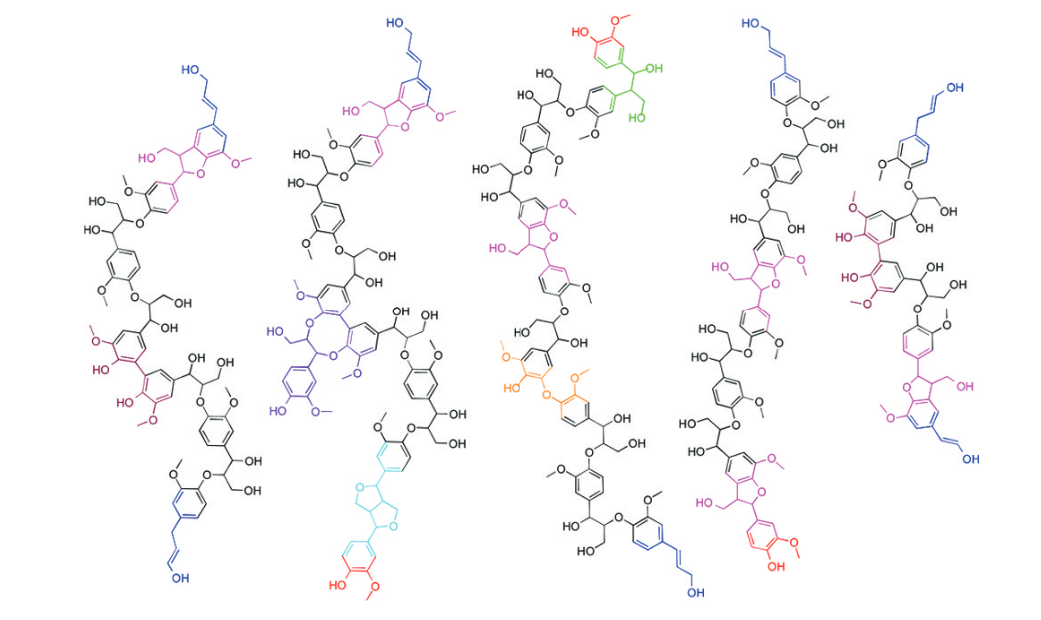
Figure 1 Example of the structure of lignin (from¹)
Nuclear Magnetic Resonance (NMR) can inform indirectly on Mw through the measurement of spin-spin relaxation times (T₂) and/or diffusion coefficients (D), making it a promising approach. However, because of lignin's complexity, the relationship between Mw and measurements accessible with NMR is not known with precision.
To solve this issue, we intend to investigate the use of Molecular Dynamics (MD) simulations. MD can be used to predict diffusion coefficients and relaxation times for lignin systems of perfectly known composition, which offers a unique opportunity to collect the data needed to calibrate the relationship between Mw and these measurements (Fig 2), and to compare them directly with experimental data.
Missions:
The goal of this internship is to perform MD simulations of lignin molecules in a solvent thanks to in order to calculate various metrics (diffusion coefficient and relaxation time) based on simulation, and to confirm these calculations by NMR measurements on lignin samples. The first part of the internship will focus on NMR measurements and simulation of known model molecules (polystyrene for instance) to establish a proof of concept on a simpler case. If these first results are promising, small molecules of lignin will be tested.
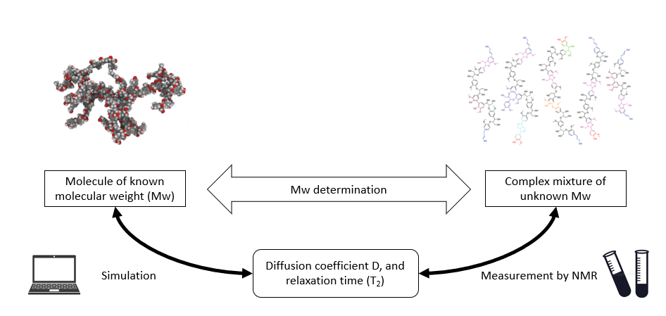
Figure 2 recap of the Internship
Experiments:
- Acquisition of NMR spectra in order to determine the diffusion coefficient (D) and spin-spin relaxation time (T₂) for:
  - Model molecules (guaiacol, syringol…)
  - Model polymers (polystyrene, polystyrene sulfonate)
  - Lignin molecules
Simulations:
- Construction of a solvent box and simulation of model molecules in this solvent box
- Simulations of model polymers, and eventually lignin molecules
- Estimation of translational diffusion coefficients and T2 relaxation times
Bibliography:
(1) Crestini, C.; Melone, F.; Sette, M.; Saladino, R. Milled Wood Lignin: A Linear Oligomer. Biomacromolecules 2011, 12 (11), 3928–3935. https://doi.org/10.1021/bm200948r.

